1. Create a package and package body in the database
2. Open JDeveloper (Version 11.1.1.7.0)
3. Create a new Application.

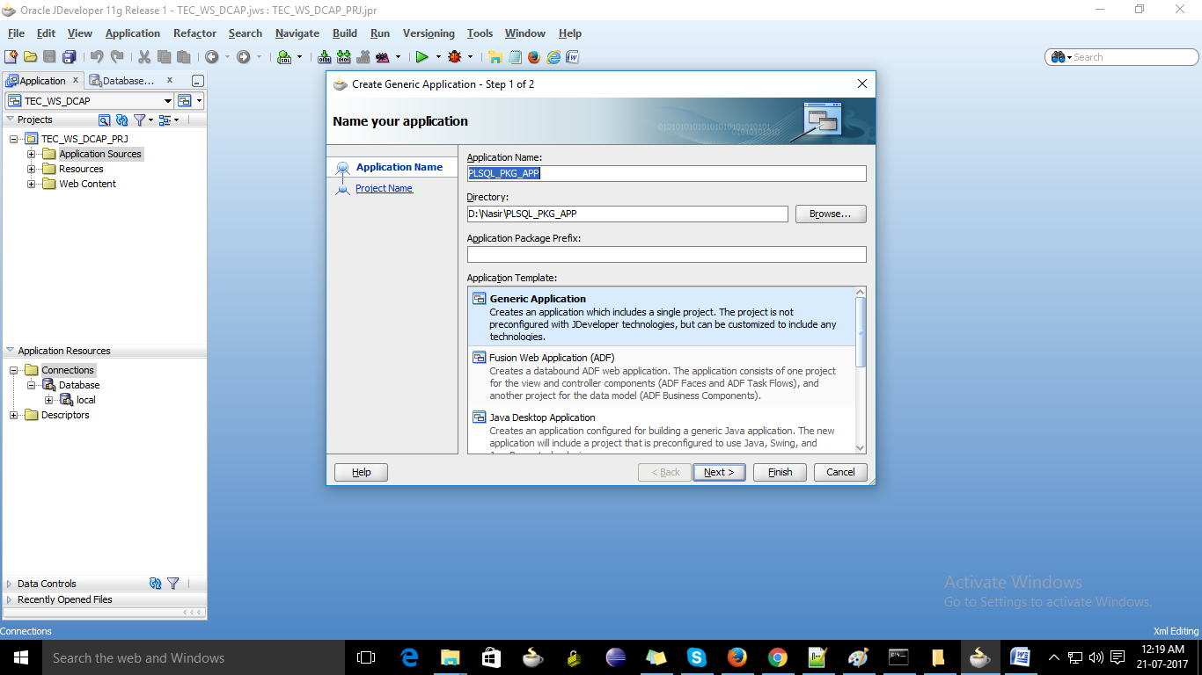

1. Create a project in Application and select the technologies as shown in screen shot.

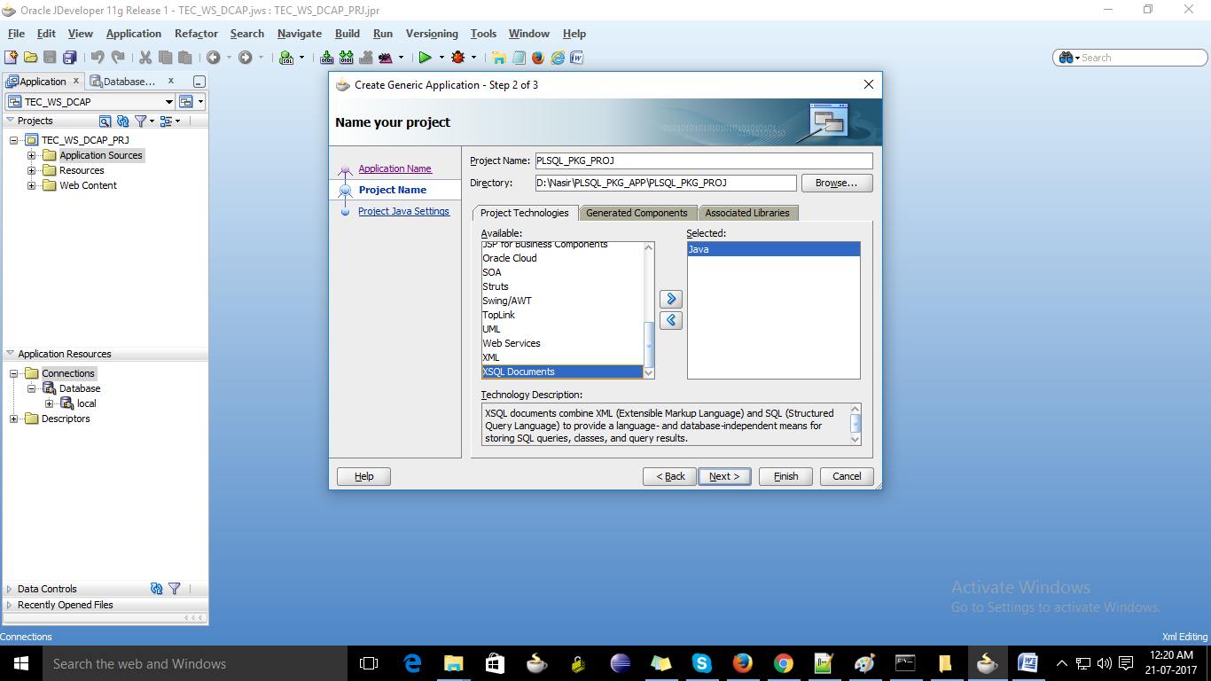

1. Select default package name and click on Finish.

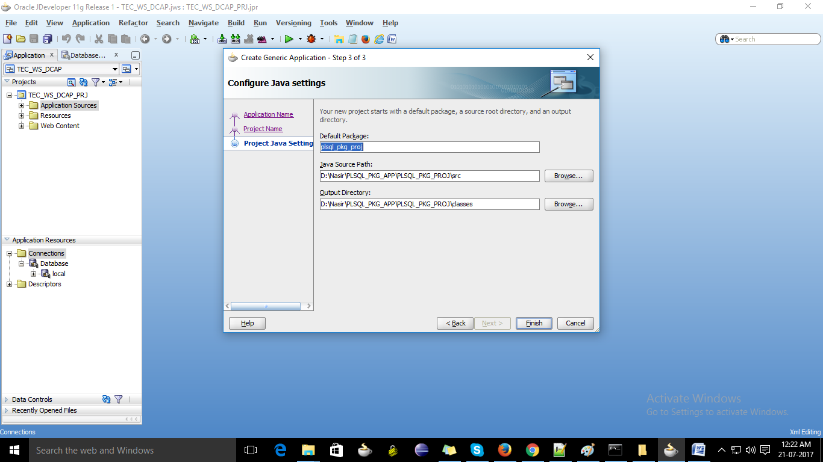

1. Go to Applicatin Resources table and right click on connections then select new connection and then Database.

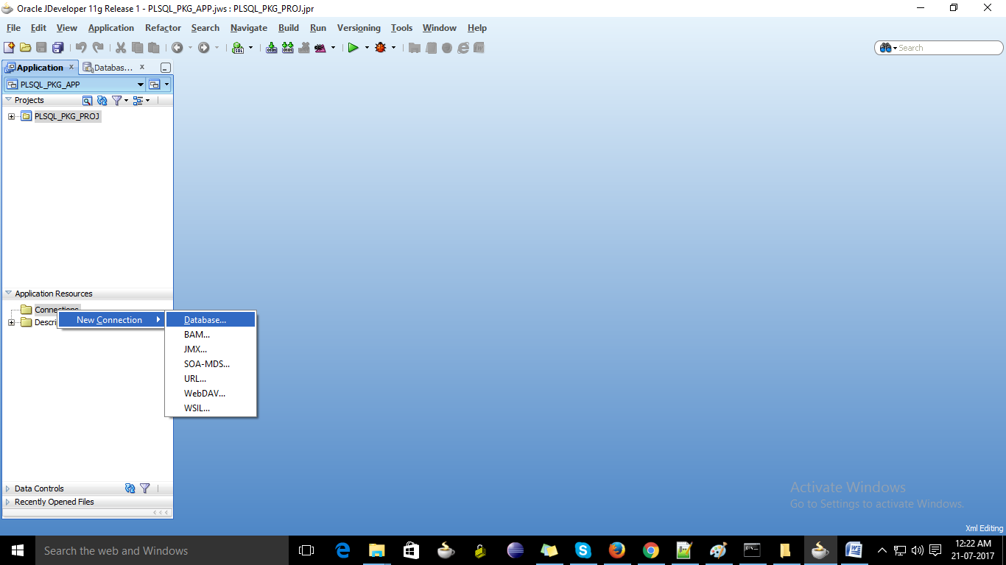

1. Enter the connection details and test whether the connection is successful or not.

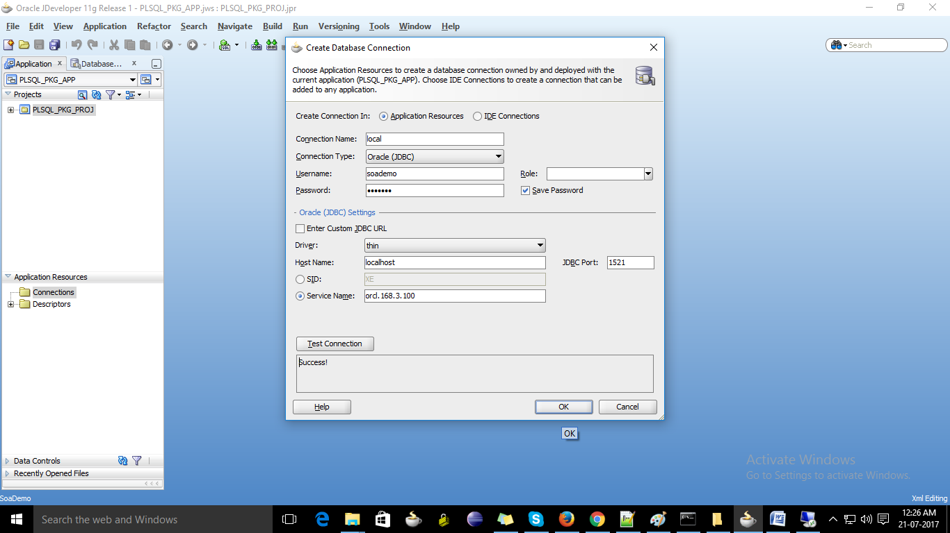

1. Once connection is successful then click ok.
2. Browse the packages from the connection created.
3. Select the package and right click on the package.
4. Select Publish as a Web Service.

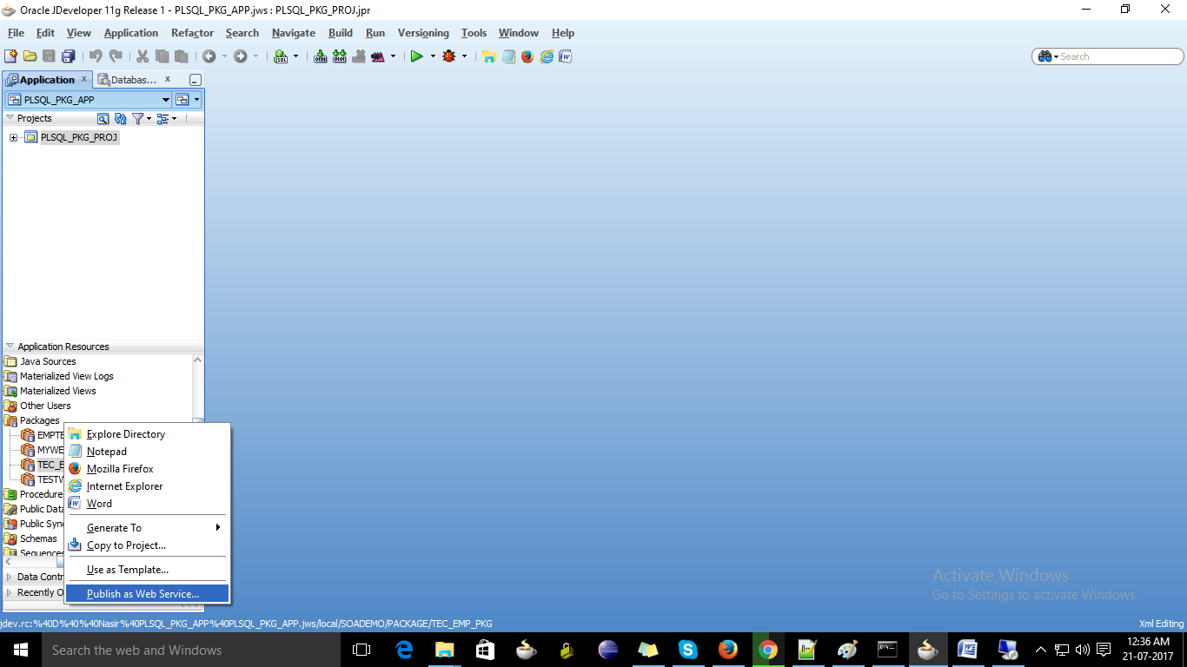

1. A wizard will open Click next.

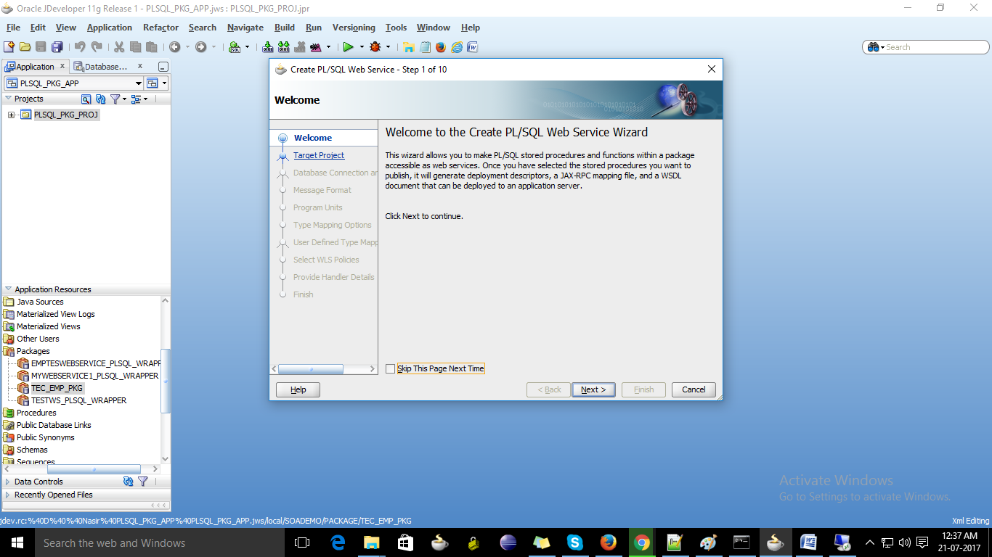

1. Select default target project created. Click on next.

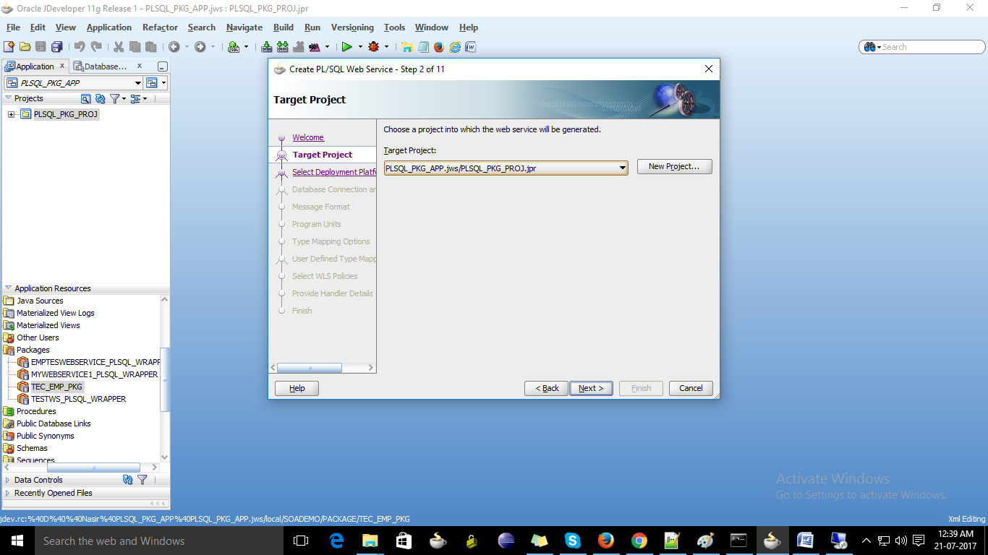

1. Select default platform and click on next.

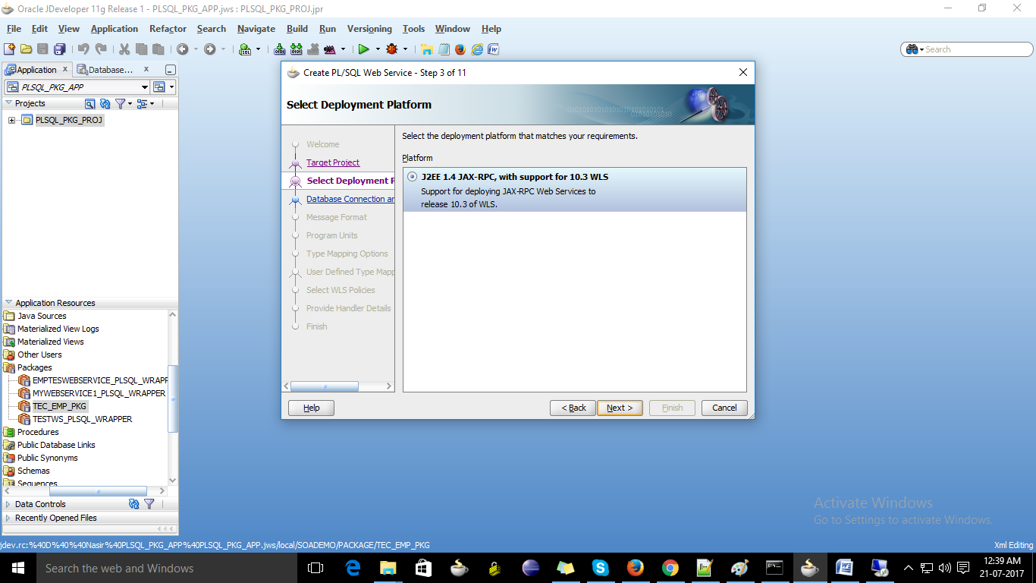

1. Give the webs service name and click on next.

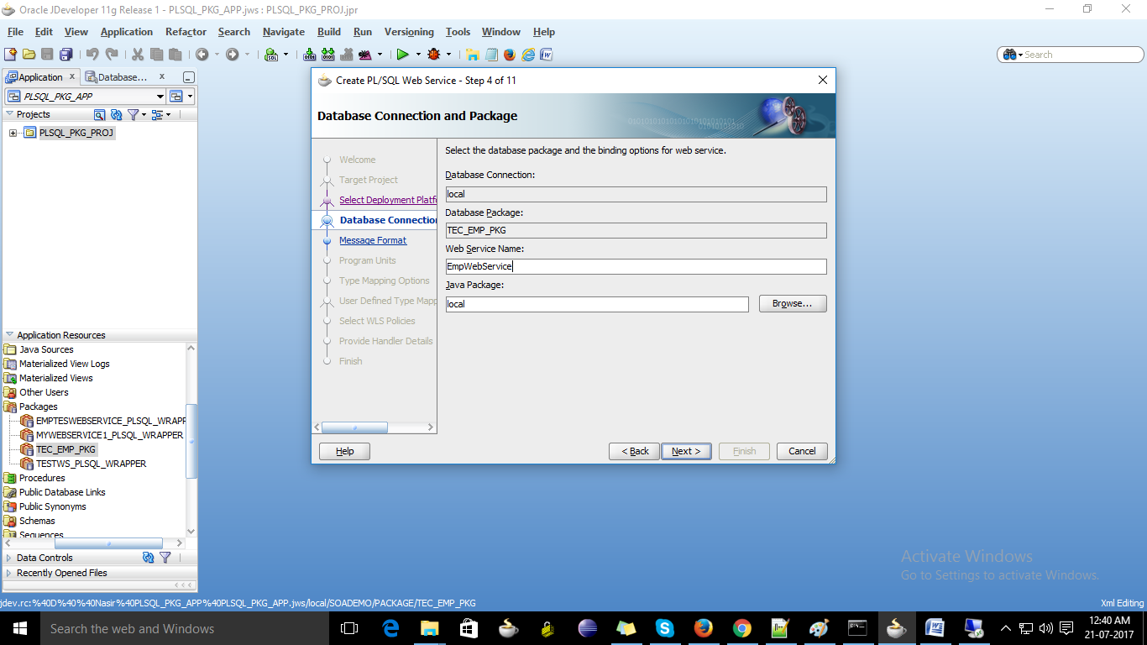

1. Select default click on next.

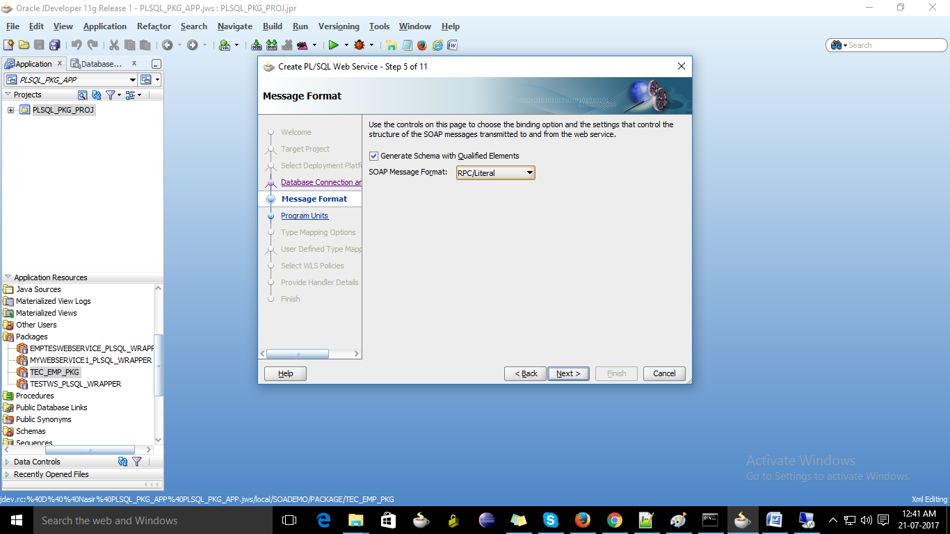

1. Check the checkbox at Available units to select the procedures/functions to execute.

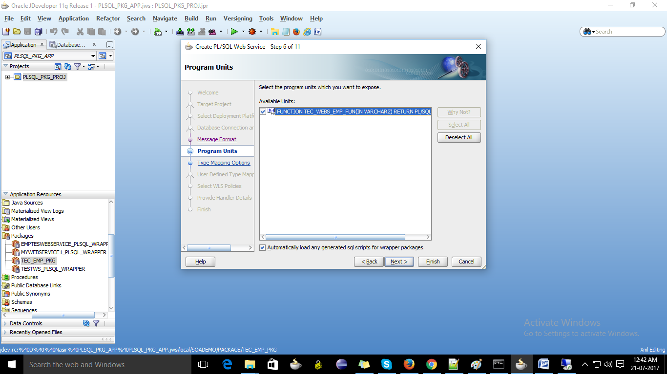

1. Select default click on next.

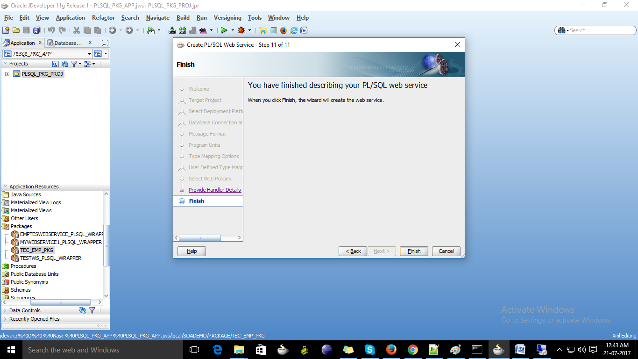

1. Select all the defaults until finish.

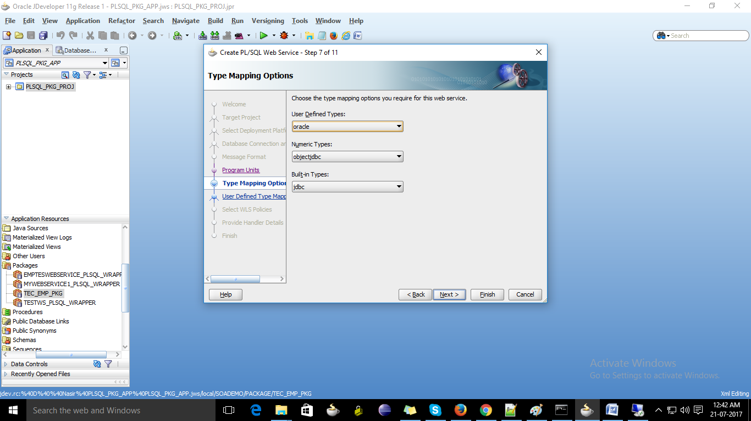

1. Web service is created.

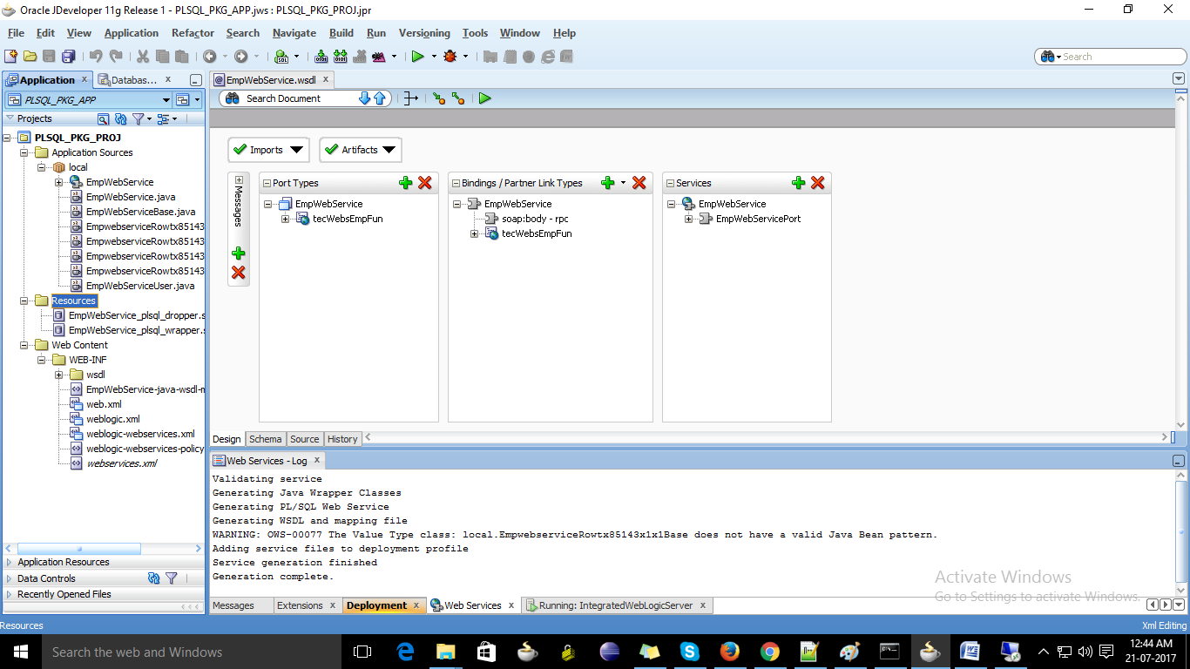

1. Right click on the project 🡪 Deploy 🡪 Webservices... 🡪 Select Deploy to WAR 🡪 Next 🡪 Finish

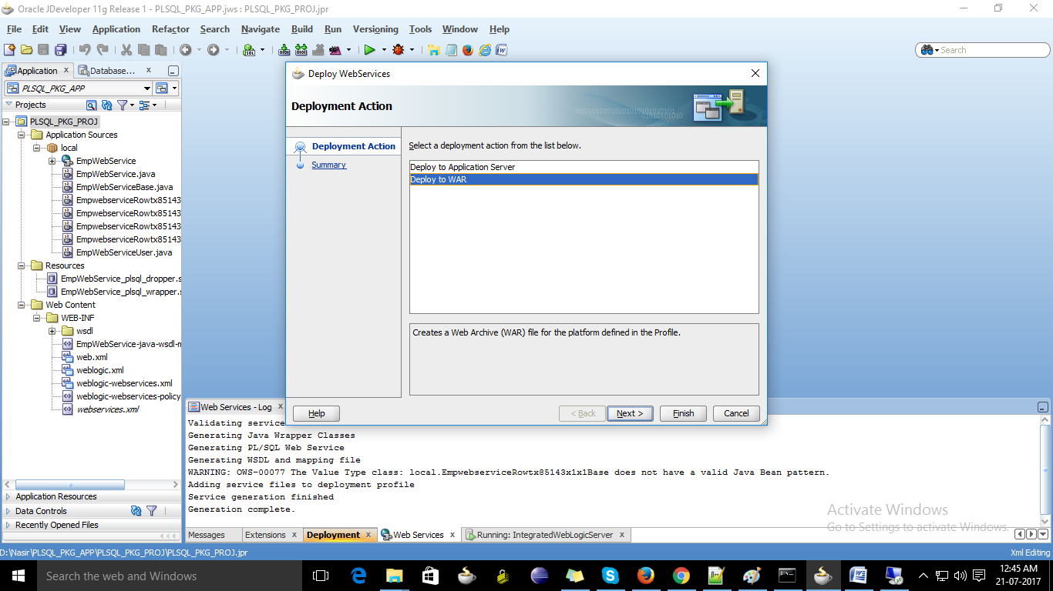

1. A folder is created as deploy which contains the war file of the project.

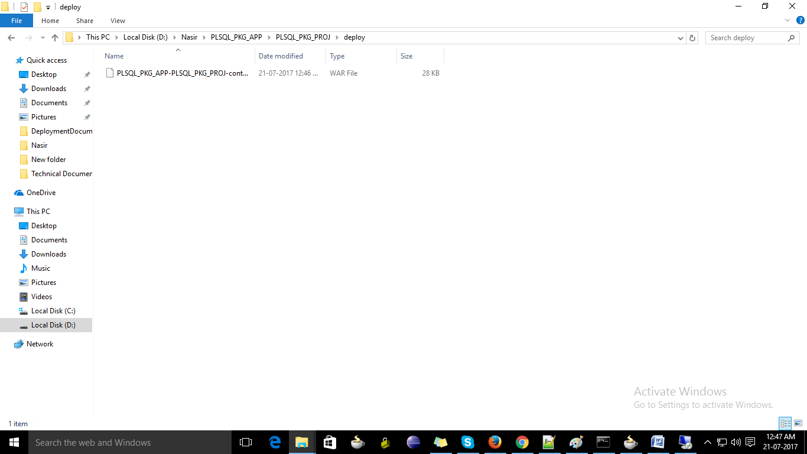

1. Got the weblogic server (Version 10.3.6) and crate the datasource with the name as you created the connectin for the jdeveloper (ex : local then create the data source name : localDS and jdbc : jdbc/localDS)

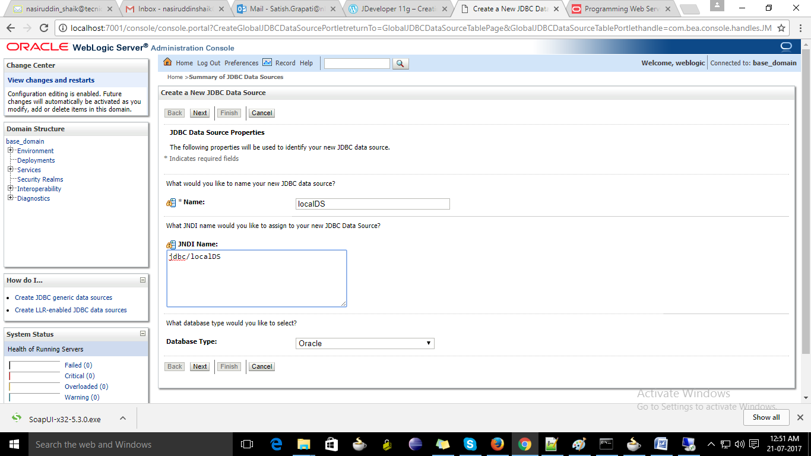

1. Click next and next.
2. Give the connection details of the database.

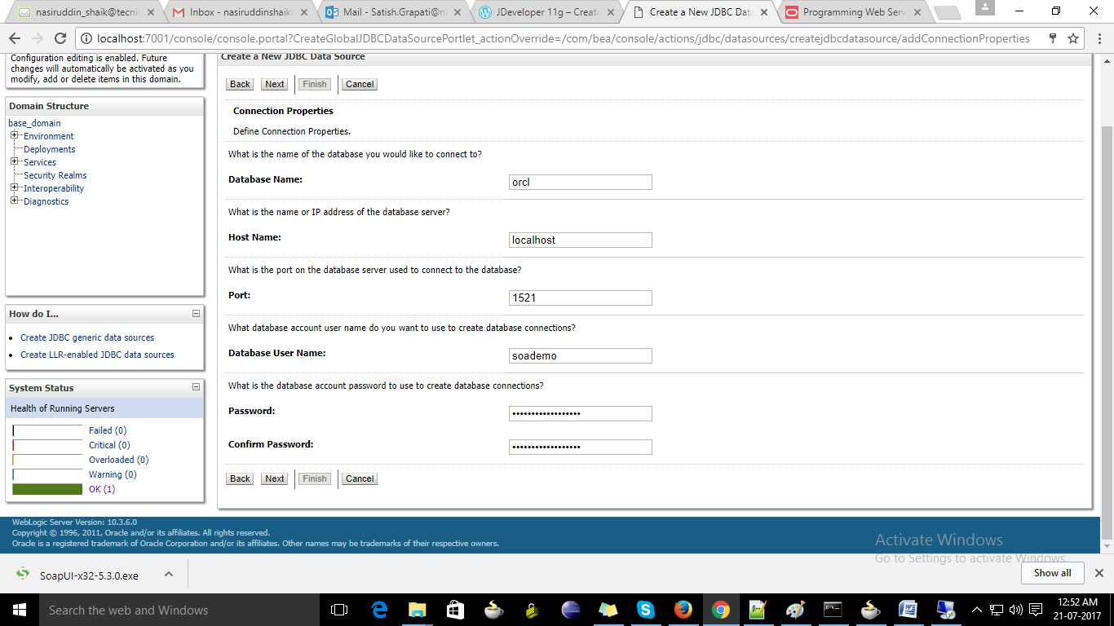

1. Click on next and next.
2. Select the server you want to deploy.

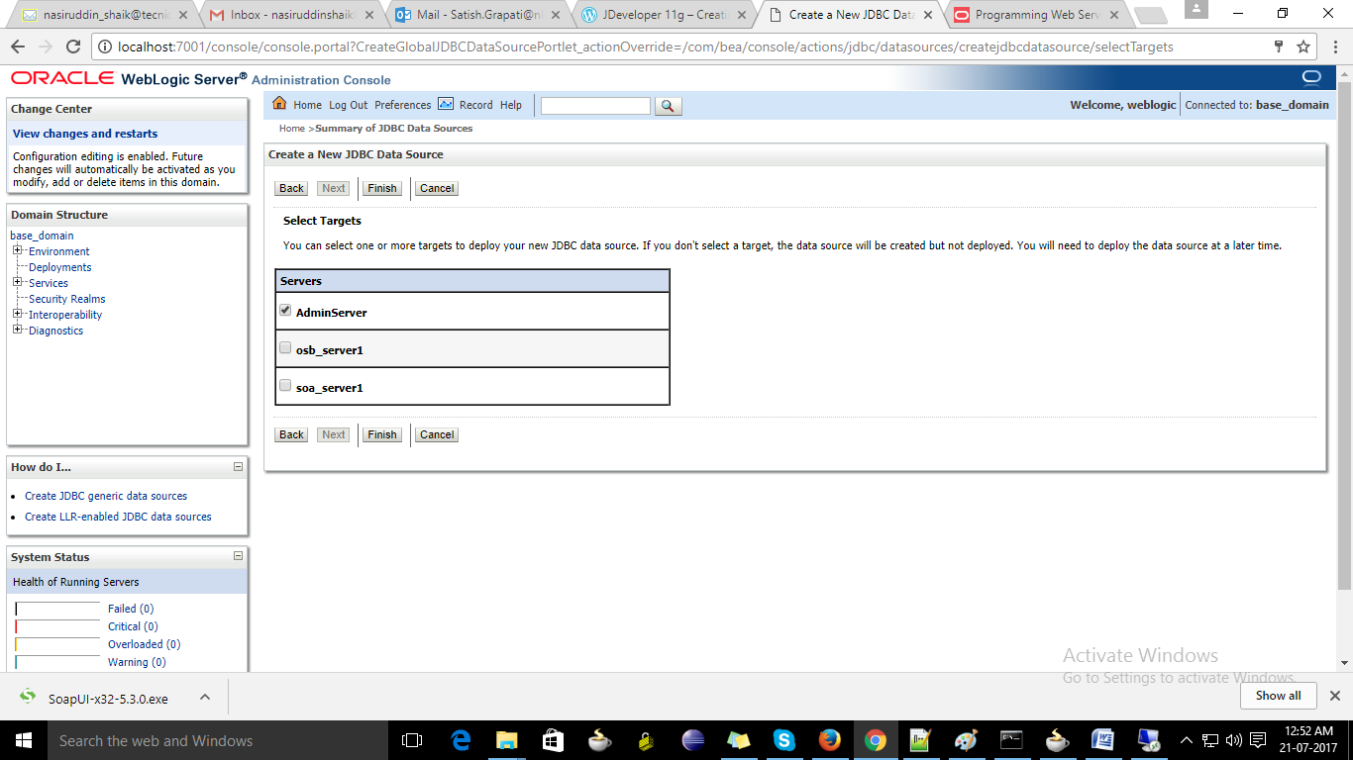

1. Click on finish.
2. You can able to see the datasource crated.

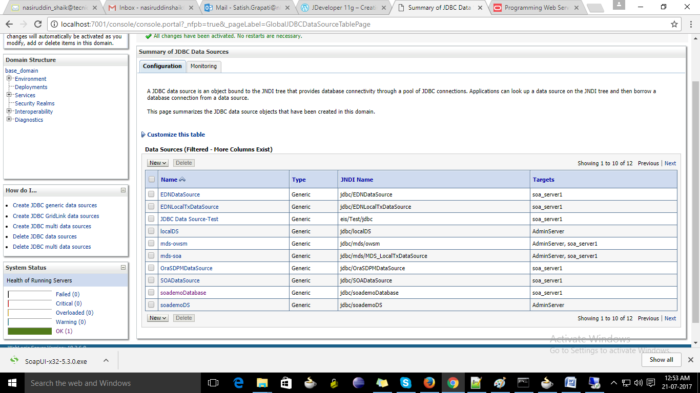

1. Click on the deployment tab on the left side menu.

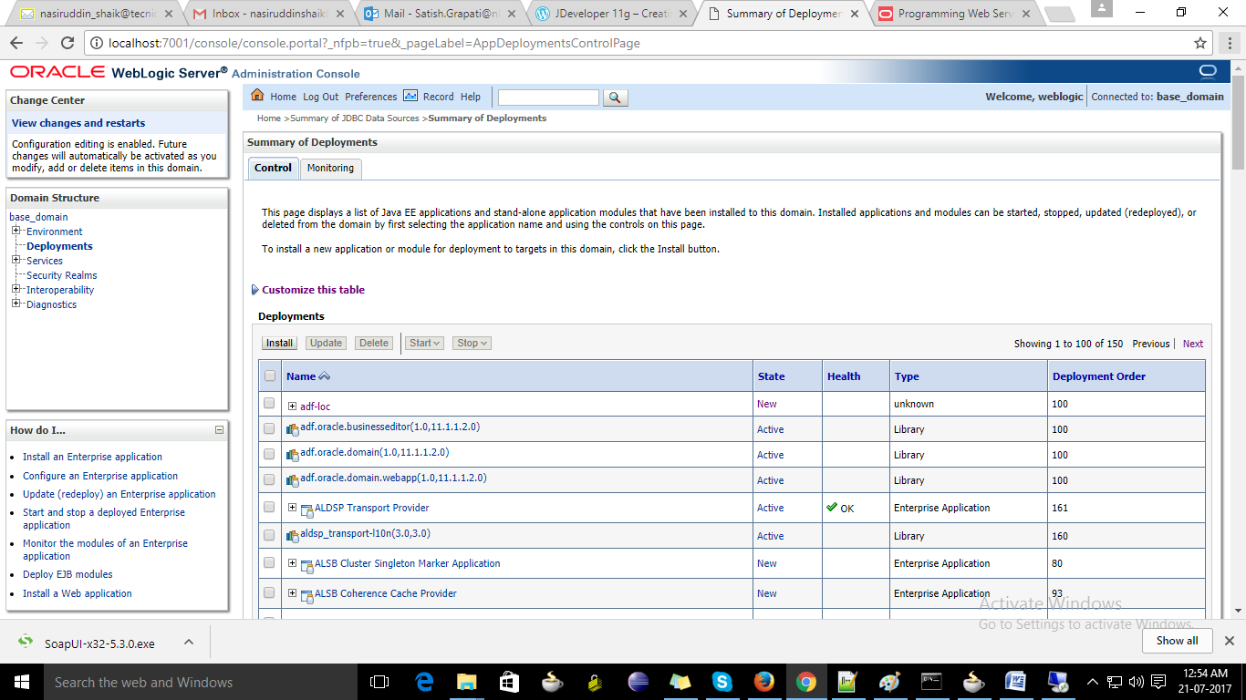

1. Click on the install button.
2. Select on the upload file from the note.

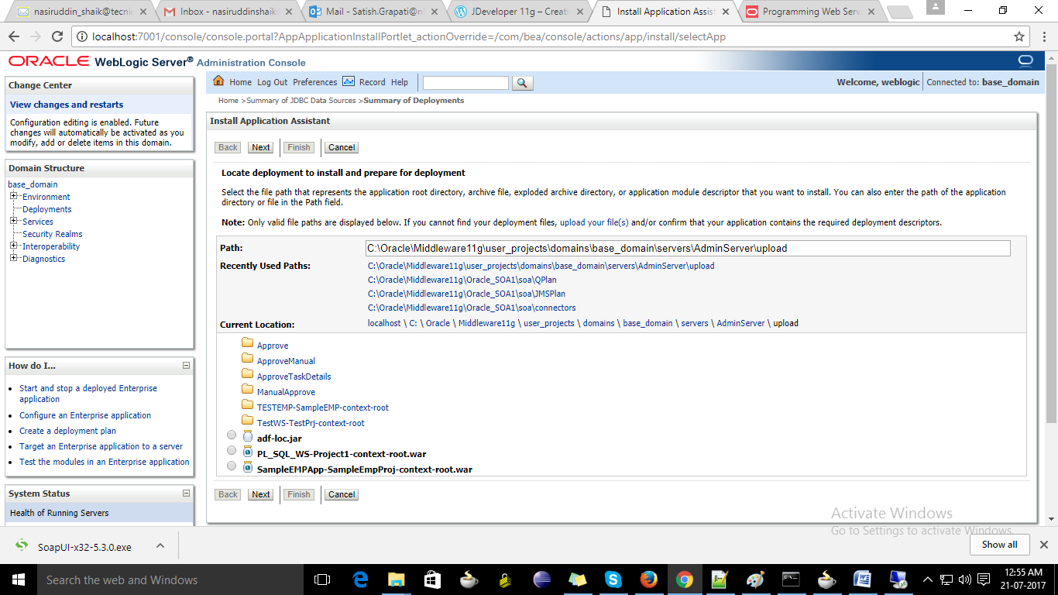

1. Select location of war file crated in developer from the browse button.

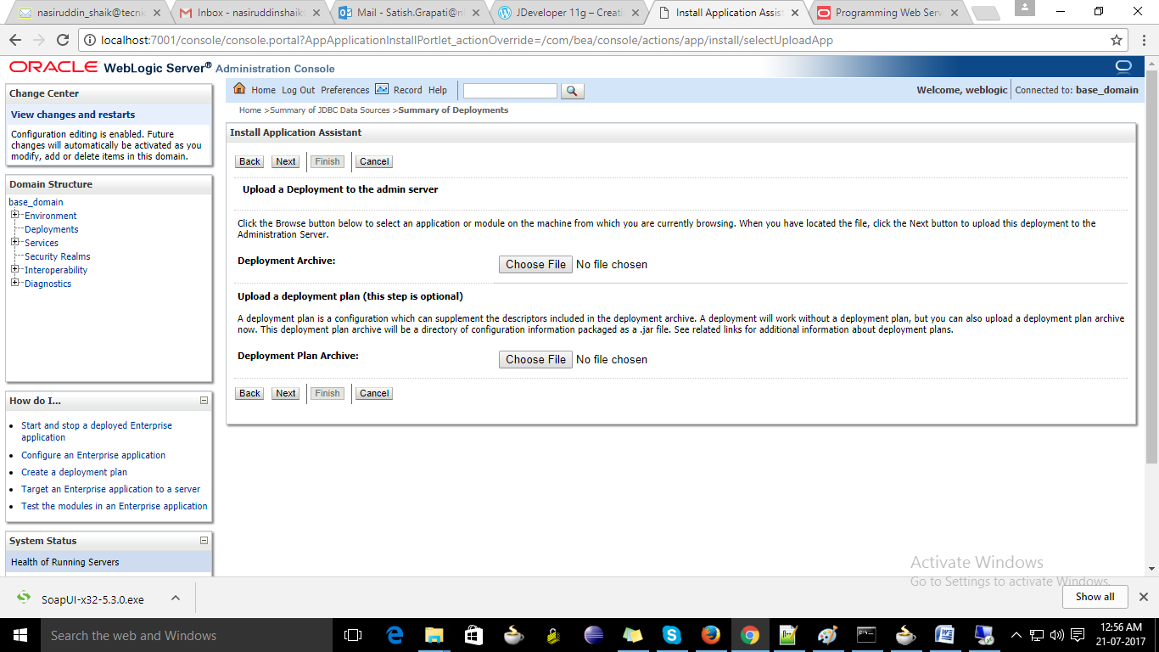

1. Click on next after selecting the war file.
2. Select defaults and click on next.
3. Select the server you want to deploy (AdminServer)

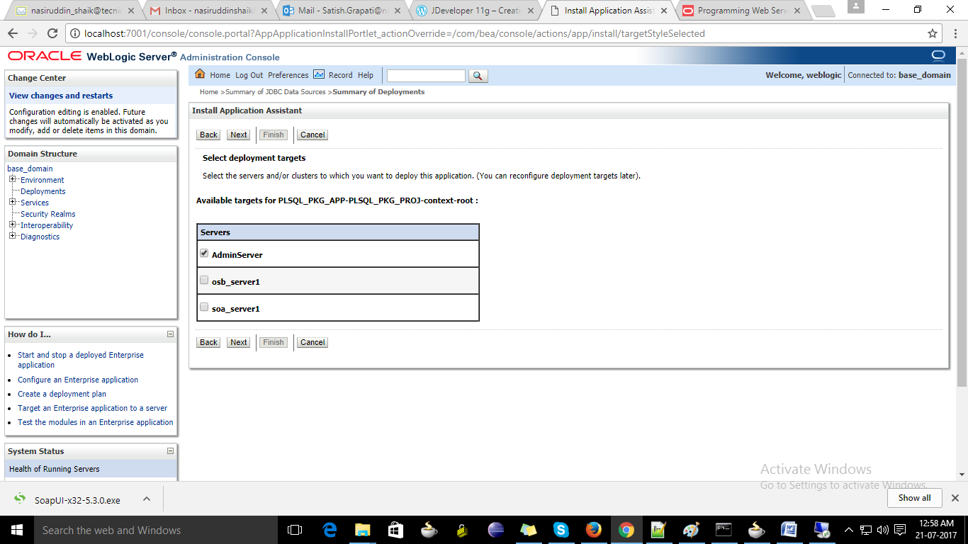

1. Select default click on next and next and finish.
2. Browse the deployment tab and you can able to see the project deployed and the status should be ‘Active’.

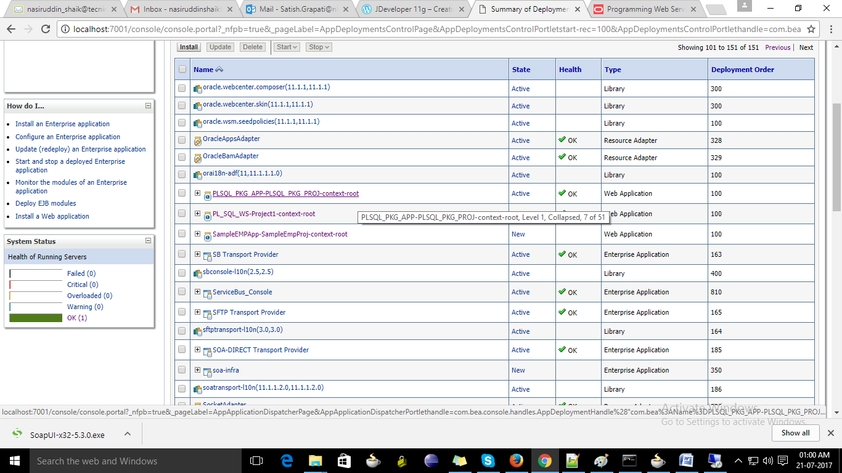

1. Click on the project and select Control tab

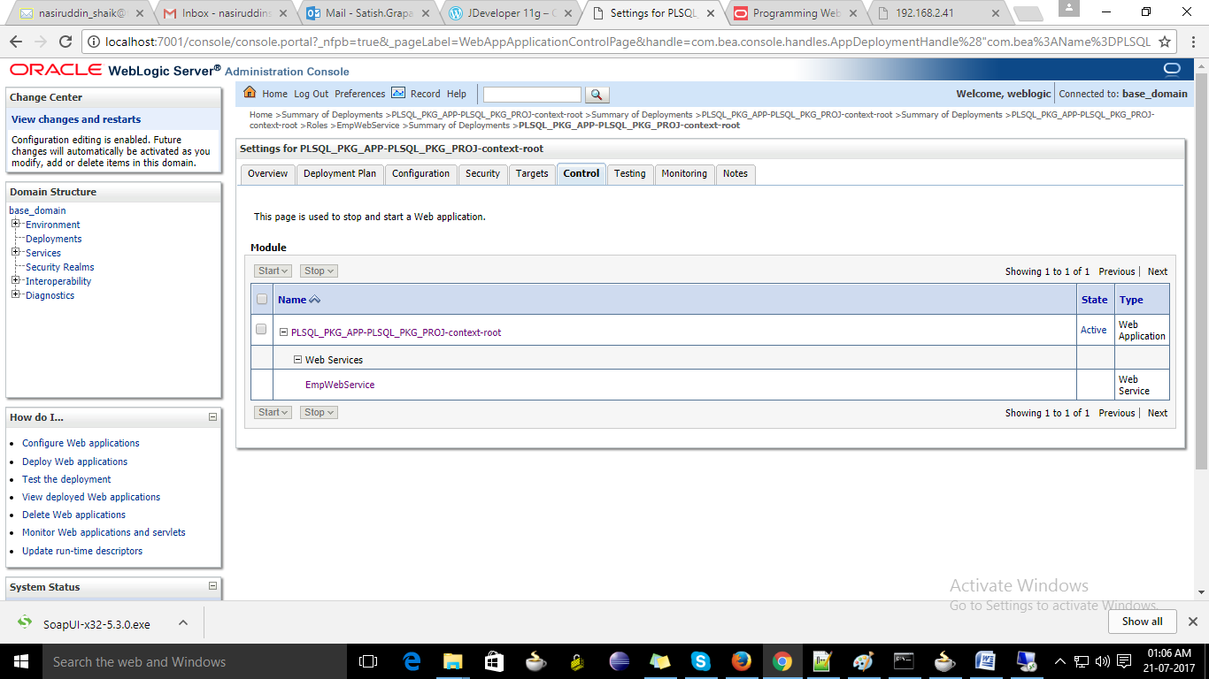

1. Click on the webservice name (EmpWebService)

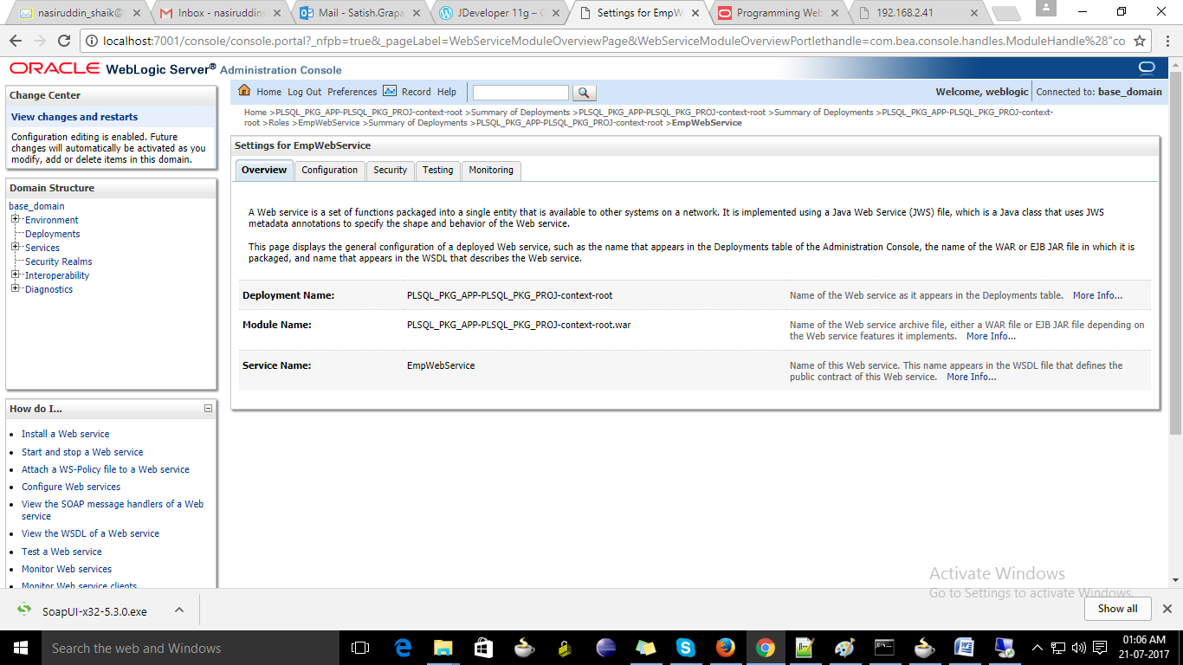

1. Click on Testing tab.

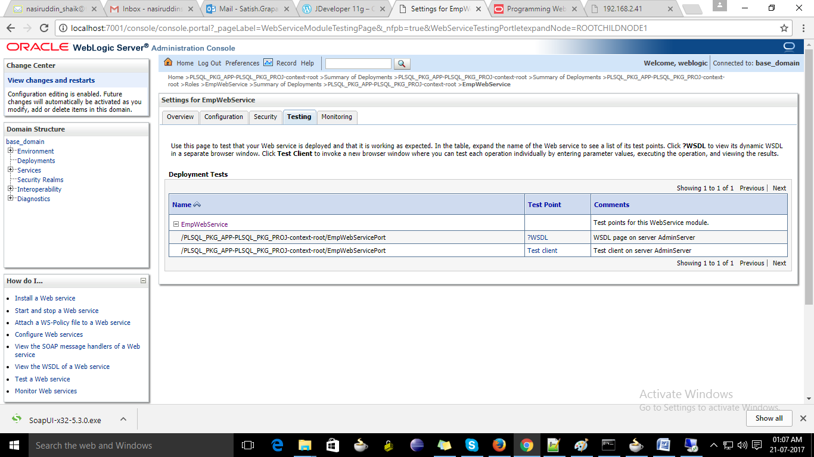

1. Click on TestClient

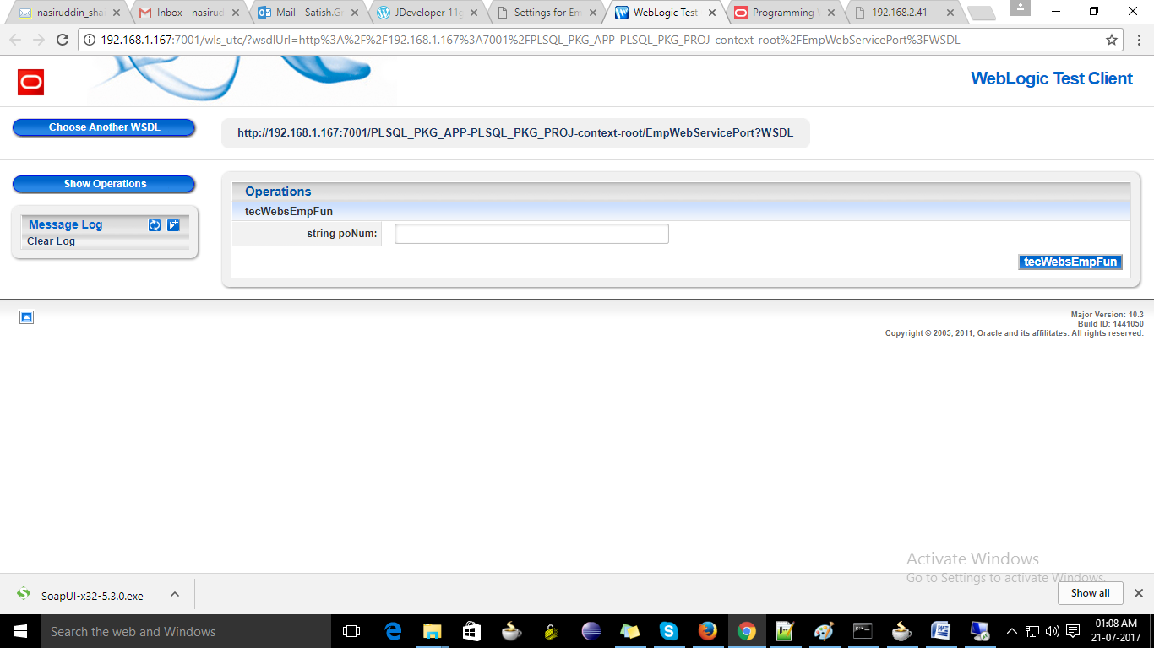

1. Enter the input and Click on button, you can able to see the output from the package

